
User Requirement Specification

Synthesis Assignment
Tutor marco Meulenbroeks
Nur Nechushtan | April 2022

Agreement with client
DuelSys Inc. requires a desktop and website application to manage sport tournaments. Initially the software should support round-robin badminton tournaments but should be extendable to other sports and systems. The desktop solution will take the form of a C# Windows Forms application, while the website will be an ASP.NET Razor Pages application. These are the key components of the project.

Functional Requirements
• FR-01: Manage Tournaments
Staff must be able to manage (CRUD operations) the tournaments.

• FR-02: Support registering players
When a player is interested in participating in a tournament, they can visit the sport association website, retrieve the list of available tournaments and register themselves for it.

• FR-03: Support generating tournament schedule
Staff must be able to generate the tournament’s schedule.

• FR-04: Support registering the results of the games
When a game between two players is finished, the results must be registered in the system by staff.

• FR-05: Support showing tournament information and results
Any interested party (e.g. a sport enthusiast, a player) must be able to retrieve information about any given tournament.

Use cases
Use Case 1: Add a new tournament  Addressing - FR-01  Actor – staff.  - The staff wants to add a new tournament  - The system shows information that need to be filled in to add a new tournament  - The staff fills in all the requirements  - The system checks if all requirements are fulfilled.  - The system adds the tournament  Extension:  3a. The inputted info is not valid.  - Error message pops up.  - Returns to step 3. | Use Case 2: Delete tournament  Addressing - FR-01  Actor – staff.  (Precondition) Use Case 1 successful  - The staff wants to delete a tournament.  - The system requests the stuff to confirm his action.  - The tournament is deleted.  Extension:  2a. The staff press the cancel button.  Stop use case. | Use Case 3: Update tournament  Addressing - FR-01  Actor – staff.  (Precondition) Use Case 1 successful  - The staff wants to update a tournament.  - The system shows information that need to be filled in to update the tournament.  - The staff fills in all the requirements.  - The system checks if all requirements are fulfilled.  - The system updates the tournament  Extension:  3a. The inputted info is not valid.  - Error message pops up.  - Returns to step 3.
Use Case 4: Display all tournaments  Addressing - FR-01  Actor – staff.  (Precondition) Use Case 1 successful  - The staff is greeted by a list of all the tournaments. | Use Case 5: User register to tournament  Addressing - FR-02  Actor – user.  (Precondition) Use Case 4 successful  - The user opens the website.  - The system shows the user a list of all the tournaments.  - The user register himself to his desired tournament.  - The system lets the user know that he was successfully registered.  Extension:  3a. The minimum number of players is reached, or the tournament has already started  - The system lets the user know that the registration failed.  - Returns to step 2. | Use Case 6: Generate tournament schedule  Addressing - FR-03  Actor – staff.  (Precondition) Use Case 4 successful  - The minimum number of players is reached.  - The staff generates the tournament schedule.  - The system generates the tournament schedule based on the tournament system.  Extension:  1a. The minimum number of players is not reached  - Use case stop.
Use Case 7: Register game result  Addressing - FR-04  Actor – staff.  (Precondition) Use Case 6 successful  - A game has finished.  - The stuff registers the result in the system.  - The system informs the staff that the result was registered.  Extension:  2a. The staff did not enter a valid result.  1. The system lets the staff know that the registration failed.  - Return to step 2. | Use Case 8: Show tournament results  Addressing - FR-05  Actor – user.  (Precondition) Use Case 7 successful  - The user opens the website.  - The user wants to see the results of a specific tournament.  - The system shows the user a table with all the played match and their results as well as a leaderboard.

Desktop application
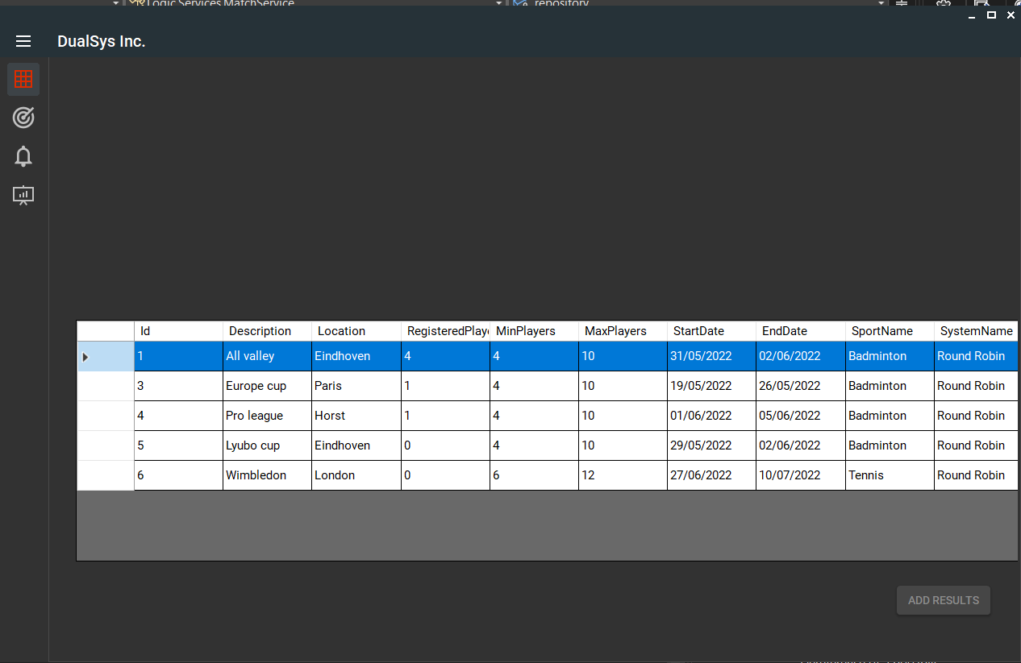
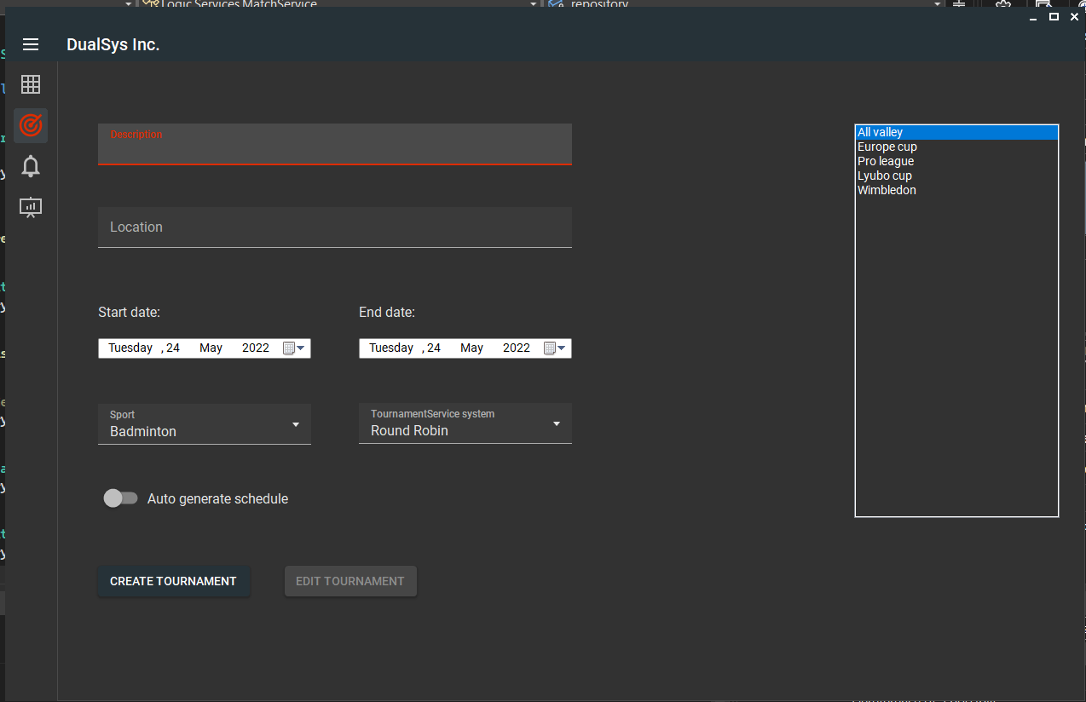

Website